The iconic DJ Donovan of TD’s Unlimited

DJ Donovan specializes in providing entertainment for a variety of events, to include:
corporate parties/events; fundraising events; and private parties.

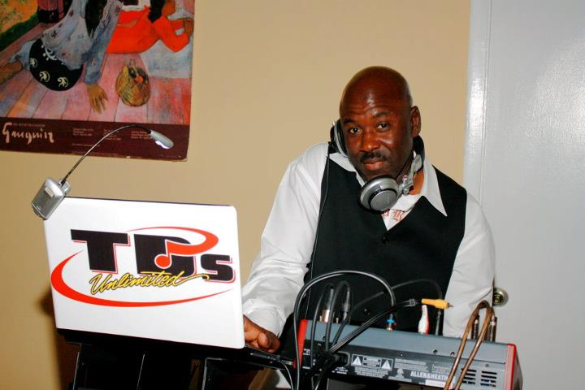
You will not be disappointed; DJ Donovan specializes in “keeping the party alive”.
Playing for the crowd is his specialty.
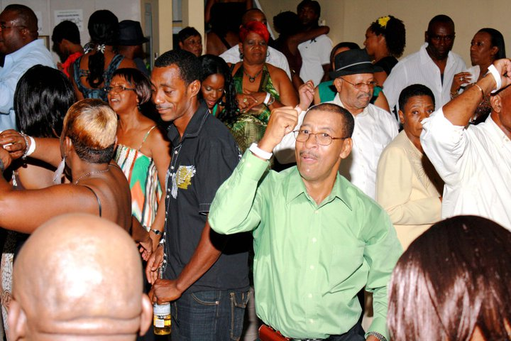
(From PS Youth’s Jamaica Independence Dinner and Dance, Aug. 6, 2011)
For booking information, please contact DJ Donovan directly at 954-548-9083.

